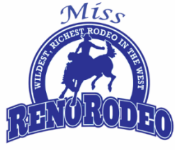

Miss Reno Rodeo 2024 Pageant- Ticket Order Form

Event: Coronation Dinner
Date: Friday, June 9th, 2023
Time: Doors open at 5:00pm, event begins at 6:00pm (no host bar)
Location: Eldorado Hotel Casino, Convention Center
Cost: Please prepay for this event.

Tickets: $55 Qt: ________ Total: $____________
Table of 10 Seats: $550 Qt: ________ Total: $____________

Name 1: ____________________________ Name 2: ____________________________

Name 3: ____________________________ Name 4: ____________________________

Name 5: ____________________________ Name 6: ____________________________

Name 7: ____________________________ Name 8: ____________________________

Name 9: ____________________________ Name 10: ___________________________

- Return form in-person at the Reno Rodeo Office, by mail to Reno Rodeo Association, P.O. Box 12335 Reno, NV 89510, or scan and email to receptionist@renorodeo.com.

*Return this order form with exact change cash, a check made out to Reno Rodeo Association for the full amount, or credit card information filled out for full amount.
TO PAY WITH CARD
TYPE OF CARD:_________________ CARD NUMBER:____________________________________
EXPIRATION DATE:______________ CVV CODE:________________________________________
BILLING ZIP CODE:______________ AMOUNT AUTHORIZED:___$_________________________
NAME ON CARD:________________________________________________
Please print clearly
SIGNATURE:____________________________________________________
Must be signed

