Special Kids Rodeo

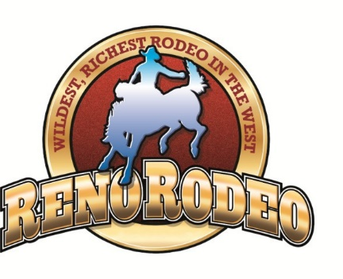
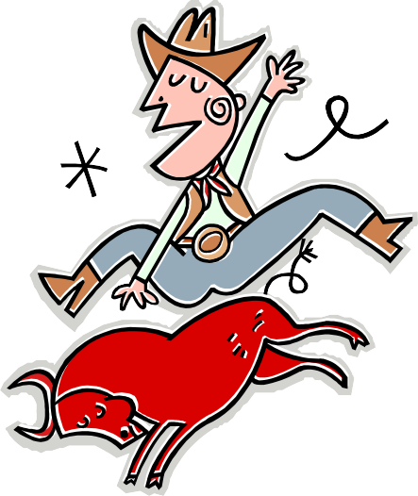
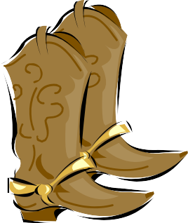

2024 SKR Sessions
Sunday, June 23rd
1:00—1:45
1:45—2:30
2:30—3:15

Space is Limited
Pre-Registration Required
Ride a Horse, Rope a Steer, Laugh and Play!
The Reno Rodeo is proud to announce the 2024 Special Kids Rodeo. Open to children and young adults under the age of 18 with special needs, this free annual event is a fun way to experience the cowboy way of life first hand.
The 2024 Special Kids Rodeo will be held on Sunday, June 23 in the Indoor Pavilion Arena at the Reno Livestock Events Center. Space is limited to 40 participants per session and
pre-registration is required.
In addition to the Special Kids Rodeo experience, participants receive a reserved seat voucher for the participant and two adults to attend the Reno Rodeo along with a "swag bag" filled with a t-shirt, cowboy hat, belt buckle, and other goodies donated by our numerous partners. Participants also receive lunch from Port of Subs.
Registration closes at 5:00 pm on May 25. Space is limited and may fill up before the deadline, so don’t delay. Siblings without special needs are welcome to be spectators; however, they may not participate - No Exceptions. If you have more than one child with special needs, please complete a separate application for each child. NOTE: If your child is afraid of animals, clowns, balloons and/or mascots, the SKR experience may not be a good fit for him/her. In June, you will receive a confirmation letter which will contain ticket vouchers, parking information, a parking pass and information about the day-of logistics.
Visit RenoRodeo.com to download an application or email RRSpecialKidsRodeo@gmail.com
The SKR experience is provided at no cost.

Yee-Haw!

